**Project Report**

**On**

**EXP - EXPLORE YOUR POTENTIAL**

**to be developed to fulfill the requirements for**

**Integrated Project (CA 329)**

**Submitted to**

**Department of Computer Applications**

**Chitkara University, Punjab**



**under the supervision of**

**Mr. Preetinder Singh Brar Mr.Naveen Kalra**

**Professor Professor**

**Submitted by**

**Mantisha Singhal Paarth Manhas Rahul Kumar Rajneesh Kapoor**

**1910981524 1910981530 1910981536 1910981539**

**Master’s of Computer Applications**

**(Batch 2019-21)**

**Template of Project Report**

1. Title Cover
2. Certificate from your guide about the submission of work done under his/her guidance, internal supervisor.
3. Table of Contents
4. Abstract of the project
5. Profile of problems assigned.
6. Study of existing system, if any.
7. System requirements
   1. Product Definition
8. Problem Statement
9. Functionality to be provided
10. Processing Environment: H/W, S/W.
11. Solution Strategy
12. Acceptance Criteria
    1. Feasibility Analysis
    2. Project Plan
13. Team Structure
14. Development Schedule/Project Timeline
15. Programming Languages And Development Tools
16. System Requirement Specifications
    1. Developing / Operating / Maintenance Environments
    2. External Interface And Data Flows
17. User display and report format, user command summary
18. High level DFD and data dictionary
    1. Functional and performance specifications
19. Design
    1. Detailed DFD’s and structure diagrams
    2. Data structures, database and file specifications
    3. Pseudo code
20. Test Plan
    1. Functional, Performance, Stress tests etc.
21. Implementation / Conversion Plan
22. Project Legacy
    1. Current status of project
    2. Remaining areas of concern
    3. Technical and managerial lessons learnt
    4. Future recommendations
23. Bibliography
24. Appendix
    1. Source Code: Each file to be listed separately

Example:

//File 001: filename.php

//Description: This file is used for ………..

//Source Code goes here

//File 002: filename.html

//Description: This file is used for ………..

//Source Code goes here

**CERTIFICATE**

This is to be certified that the project entitled “**Explore Your Potential**” has been submitted for the Master’s of Computer Applications at Chitkara University, Punjab during the academic semester January-June 2020 is a bonafide piece of project work carried out by group Members **Mantisha Singhal (1910981524**),**Paarth Manhas (1910981530)** ,**Rahul Kumar(1910981536), Rajneesh Kapoor(1910981539)** towards the partial fulfillment for the award of the course Integrated Project (CA-329) under the guidance and supervision of **Mr. Preetinder singh brar and Mr. Naveen Kalra.**

**Mr.** **Preetinder singh brar**  **Mr. Naveen Kalra.**

Professor Professor

**4.Abstract:**

The career-guidance is one of the bridges between the professional-market and the educational sphere. This abstract is based on the methods of the career-guidance among the students at the beginning and at the end of their educational period during the entire period of study with the taking into account the requirements of students professional skills which should be possessed by future graduates;  how career guidance helps students understand the social significance and the content of their chosen profession during the educational period and how this understanding contributes to the students' motivation to the acquisition professional skills; will the enough of those professional skills that students gain in the university for to meets the needs of the market or they needs to obtain for additional professional skills.

**5.Profile of Problem Assigned:**

|  |  |  |  |  |
| --- | --- | --- | --- | --- |
| Member’s | Database | Design | Computer  Programming | Testing |
| RAHUL |  | ✓ |  | ✓ |
| RAJNEESH | ✓ |  | ✓ |  |
| PAARTH | ✓ |  | ✓ |  |
| MANTISHA |  | ✓ | ✓ |  |

**6.Study of Existing System:**

There are few websites that the team has tried to study are mindler.com, idreamcareer.com and etc. These websites were complex and time consuming for the kids and whereas our platform takes a short psychometric test to evaluate their field of interest and guide them to a brighter future with involving a chat system with our experts.

These Websites helped us through the different fields and concepts to be applied.

**7. System Requirements:**

**A. Product Definition:** Career Guidance platform with method of Psychometric test evaluation technique to guide the User for which career to opt.

**a) Problem statement:** Now a days, students are not aware of their career opportunities they have for themselves or where there heart resides apart from passion.so to overcome the problem of various career options a website based on career counselling is build to show the right path by guiding them through various fields through psychometric test.

**b) Functionality:**

**Customers:** These include our end-users like **students** and **parents**. They can register themselves onto the platform and reap benefits our services for free.

**Experts:** These include associated professors or professionals who’ll help with our expert interaction features and help in guiding the customers.

**Admin:** An administrator account, to validate contents posted by customers and rights to ban/unban their accounts. Also, he shall be able to add a new expert account for any professional who wants to join the cause.

**Location:** This system will be available to any potential customer using the internet for free. However, to access the services provided by the system, end-user will have to be registered.

**Need:** This system is needed to help the students pick a career path best fitted to their talents/interests. Because if one gets into a field which he/she doesn’t love, he/she is bound to be unhappy all his/her life (count stress and insomnia as bonus).

**Reliability:** The system shall be completely operational most of the time. Down time after a failure shall not exceed more than 24 hours.

**Usability:** Customers should be able to use the system easily without having to provide them any prior training.

**Security:** All the assessment results shall only be visible to the respective registered users or their parents and shall be masked from the other registered users completely.

**Supportability:** The system web site shall be viewable/accessible from all the mainstream web-browsers including Google Chrome, Mozilla Firefox, Microsoft Edge, Apple Safari, etc.

**Online user documentation and help:** The system shall provide a web page that explains how to navigate the site.

**c) Processing Environment:**

**1.Client End:**

* Processor: Intel Core i3 or above.
* Operating System: Windows 7/Windows 8/Windows 10/Ubuntu/Mac.
* Memory: 2GB RAM
* Hard Disk Space: 20GB
* Browser: Safari/Chrome/Mozilla/Internet Explorer

**2.Server End**:

* Processor: Intel core i3 or above
* Operating System: Windows 7/Windows 8/Windows 10/Ubuntu/Mac.
* Memory: 2GB RAM.
* Hard Disk Space: 20GB
* Database: MySQL server
* Software Version: Xampp(v5.6.20)

**d) Acceptance Criteria:**

The Platform is Used by the kids to see the career choice they have and by parents to view results. Basically

Users below age 18 and their parents and experts for guidance.

**B. Feasibility Analysis**

A feasibility study is a high-level capsule version of the entire system analysis and design process. The study begins by classifying the problem definition. Feasibility is to determine if it’s worth doing. Once an acceptance problem definition has been generated, the analyst develops a logical model of the system. A search for alternatives is analyzed carefully.

There are 3 parts in feasibility study.

* **Operational Feasibility:**

Question that going to be asked are

* Will the system be used if it developed and implemented.
* If there was sufficient support for the project from the management and from the users.
* Have the users been involved in planning and development of the Project.
* **Technical feasibility:**
* Does the necessary technology exist to do what is been suggested.?
* Does the proposed equipment have the technical capacity for using the new system?
* Are there technical guarantees of accuracy, reliability and data security?
* The project is developed on intel core i5(7th Generation) with 8GB RAM.
* The environment required in the development of system is any windows platform or any other operating system.
* The user pattern along with admin pattern will update the results eventually.
* The language used in the development is PHP, HTM, JQUERY, JAVASCRIPT and database as MySQL server.
* **Economical Feasibility:**
* To decide whether a project is economically feasible, to consider various factors as cost benefit analysis, long-term returns and maintenance costs.

**C. Project Plan:**

**a). Team Structure:**

It was a Matrix organisation Structure which is different from Traditional Structure of work.

The information was collected and given to the design team for the outlet of website the design team would pass the work to database admin for database structure and side by side backend developer where the work was assigned on units.

**b). Programming Languages:**

**Backend:**

PHP , JavaScript ,JQuery

**Frontend:**

CSS, Html

**Database:**

MySql

XAMPP

**8. CONTEXT DIAGRAM**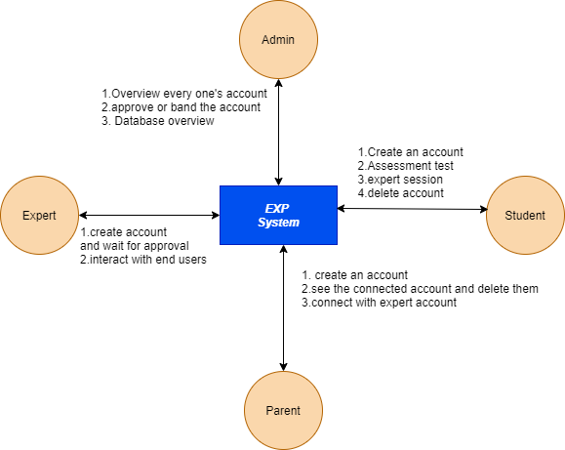

**SITE FLOW**

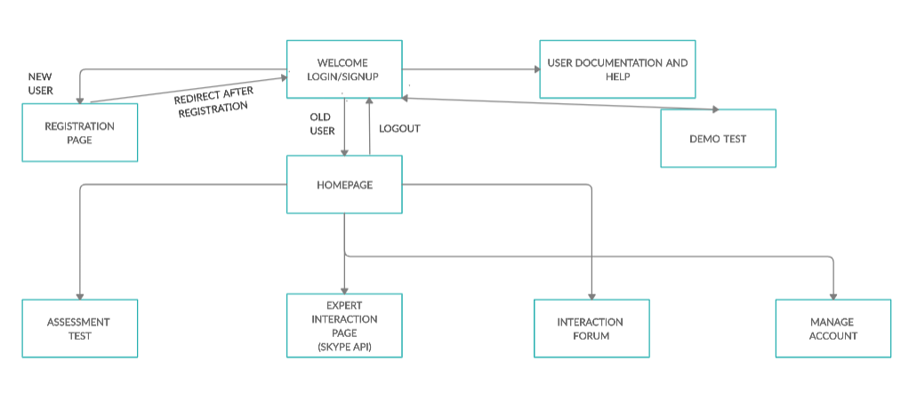

**9. PHASES**

This project has been divided into a set of phases so as to ensure end-system’s smooth roll out.

* Phase 1 – Working prototype for Students.
* Phase 2 – Integrate parent’s and Expert access into the system.
* Phase 3 – Add functionality for Aptitude test also (Pending).

**10. DATABASE & DESIGN (TABLE STRUCTURES)**

**10.1 End-User table**

|  |  |  |
| --- | --- | --- |
| **Fields** | **Data-Type** | **Constraints** |
| User_Id | Integer | Primary Key |
| First_Name | Varchar | Not Null |
| Last_Name | Varchar | Not Null |
| Dob | date | Not Null |
| Email_Id | Varchar | Unique/Not Null |
| Phone_No | Integer | Unique/Not Null |
| Password | Varchar | Unique |
| Role | Integer | Not Null |
| Account_Status | Integer | - |

**10.2 Expert Table**

|  |  |  |
| --- | --- | --- |
| **Fields** | **Data-Type** | **Constraints** |
| Expert_Id | Integer | Primary Key |
| First_Name | Varchar | Not Null |
| Last_Name | Varchar | Not Null |
| Dob | date | Not Null |
| Email_Address | Varchar | Unique/Not Null |
| Password | Integer | Not Null |
| Phone_no | Varchar | Unique |
| Profession | Varchar | Not Null |
| Experience | Integer | Not Null |
| Role | Integer | Default=3 |
| Account Status | Integer | Not Null |

**10.3 Questions Table**

|  |  |  |
| --- | --- | --- |
| **Fields** | **Data-Type** | **Constraints** |
| Serial_no | Integer | Primary Key |
| questions | Varchar | Not Null |

**10.4 Relationship Table**

|  |  |  |
| --- | --- | --- |
| **Field** | **Data-type** | **Constraint** |
| s_no | integer | Primary key |
| parent_id | integer | Not null |
| student_id | integer | Nut null |

**10.5 Report Table**

|  |  |  |
| --- | --- | --- |
| **Fields** | **Data-Type** | **Constraints** |
| User_id | Integer | Primary Key |
| Personality | Varchar | Not Null |
| remarks | Varchar | Not Null |

**10.6 Bios Table**

|  |  |  |
| --- | --- | --- |
| **Fields** | **Data-Type** | **Constraints** |
| User_id | Integer | Primary Key |
| bio | Varchar | Not Null |

**10.7 Queries Table**

|  |  |  |
| --- | --- | --- |
| **Fields** | **Data-Type** | **Constraints** |
| S_no | Integer | Primary Key |
| User_id | Integer | Not Null |
| Query | Varcahar | Not Null |
| Timestamp | Timestamp | Not Null |
| Skype_name | Varchar | Not Null |
| Query_status | Integer | Not Null |

**DATABASE STRUCTURE:**

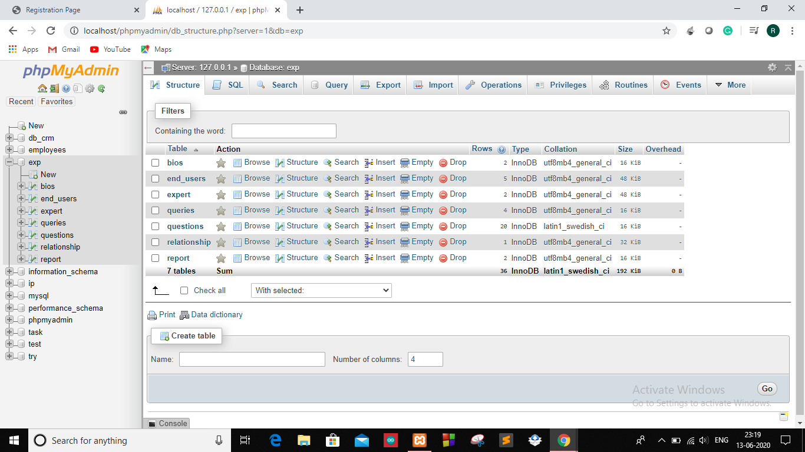

**WEBSITE REPRESENTATION:**

**1.Homepage:**

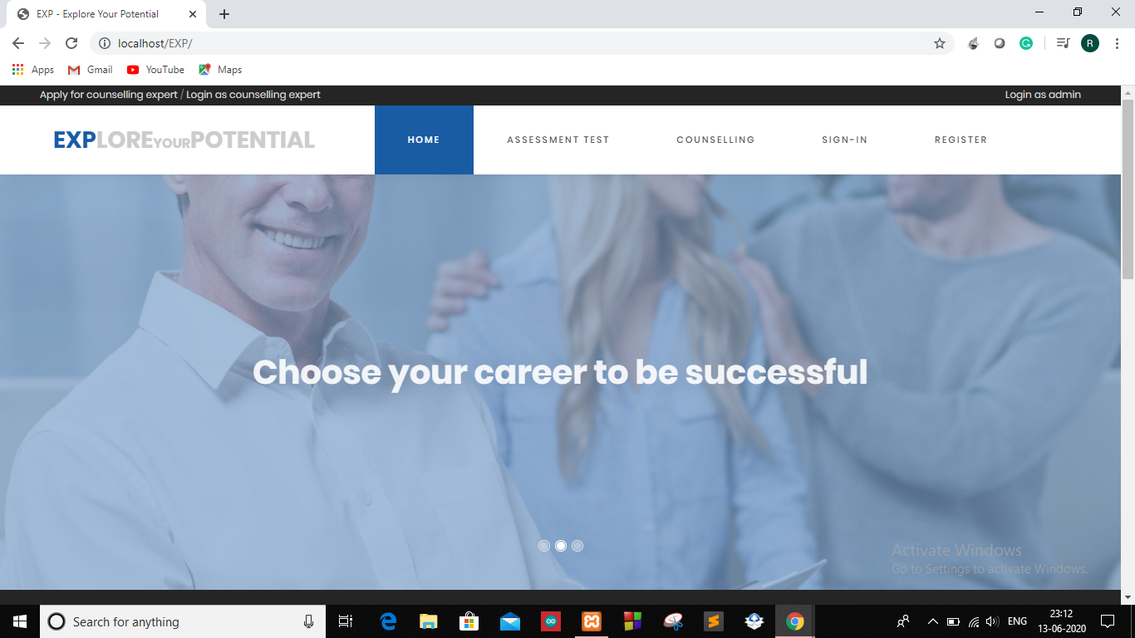

**2.Register and Login Page**

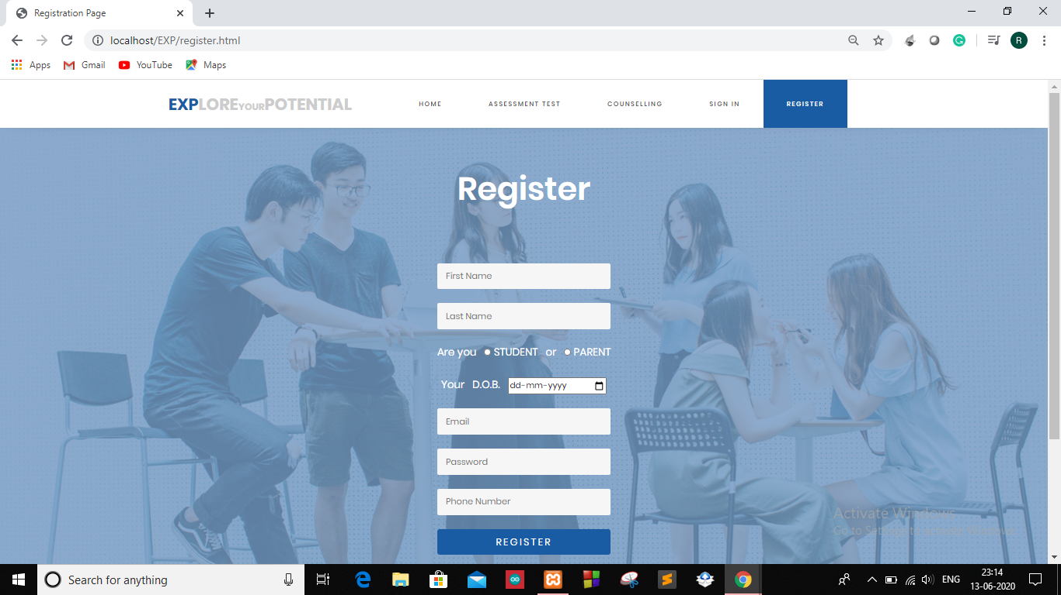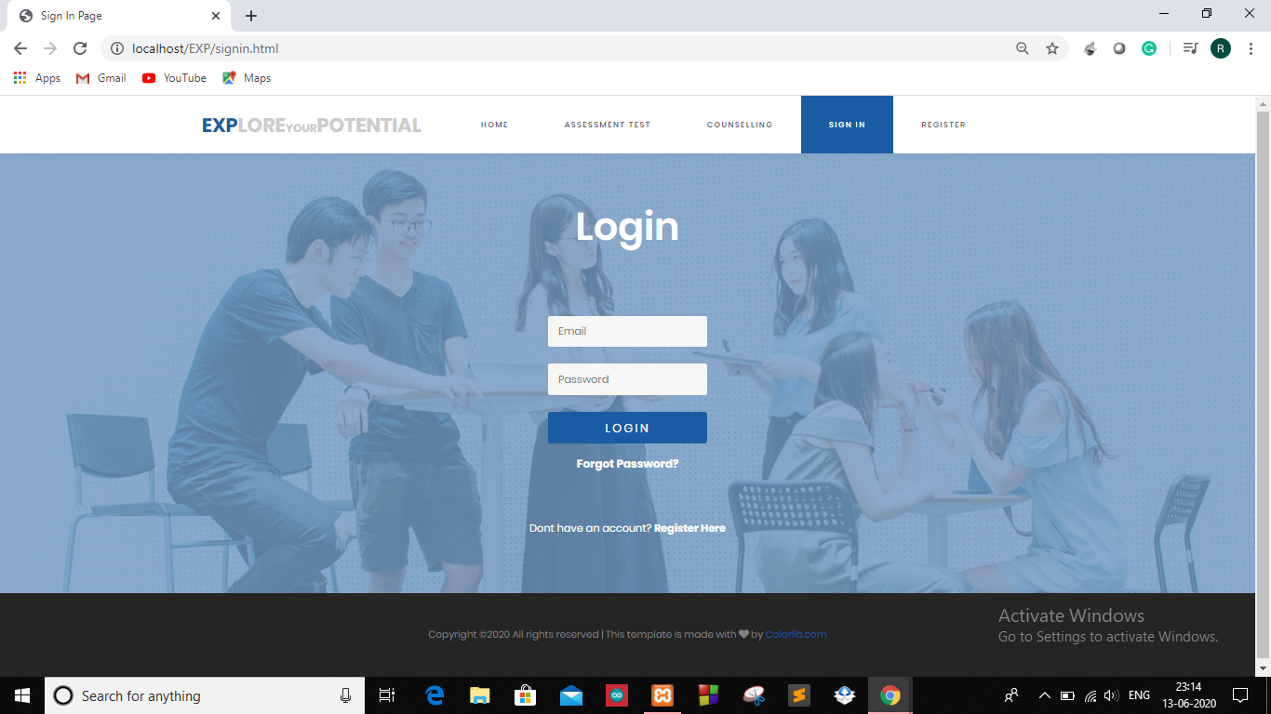

**3.Forgot Password:**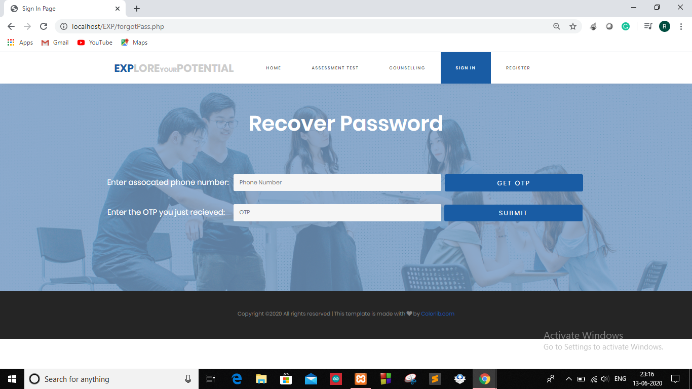

**4. Student Page:**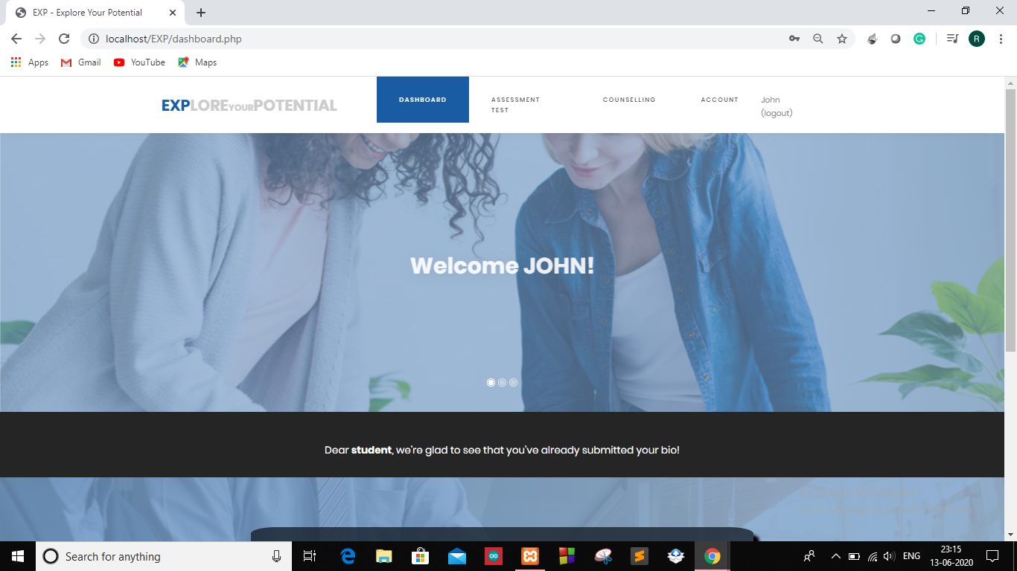

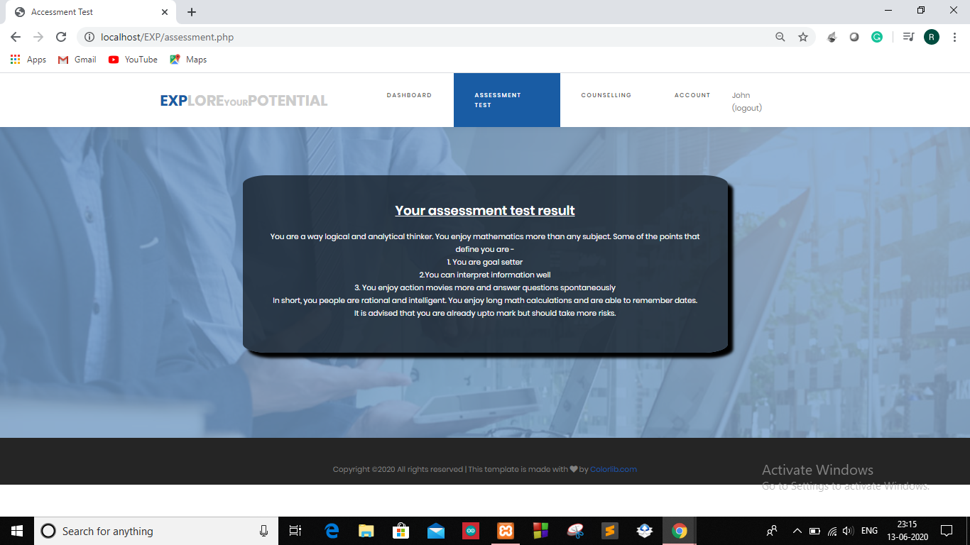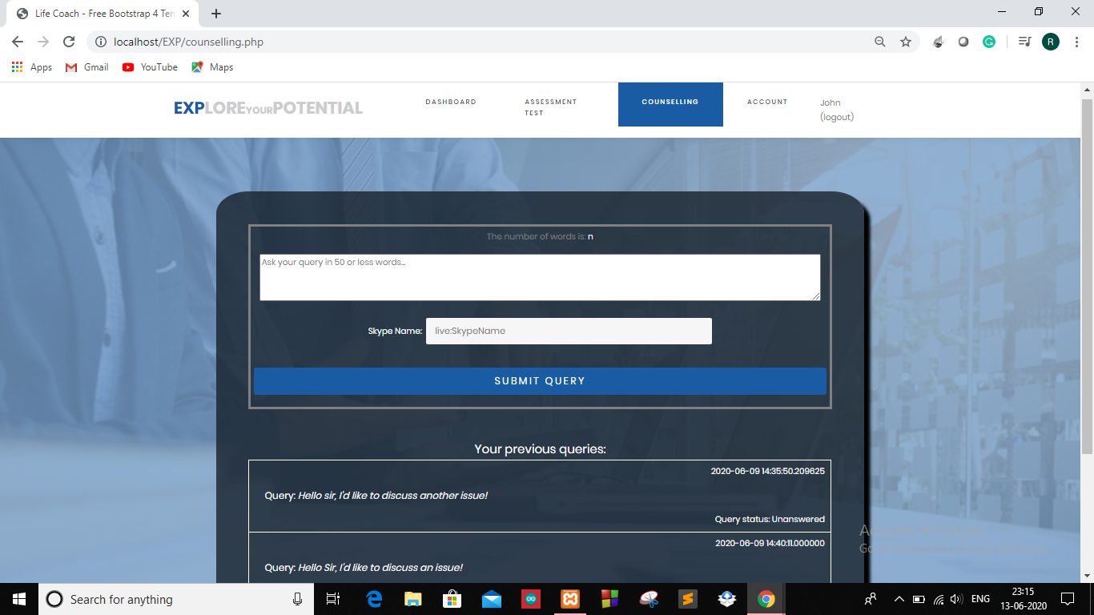

**5.Parent page:** 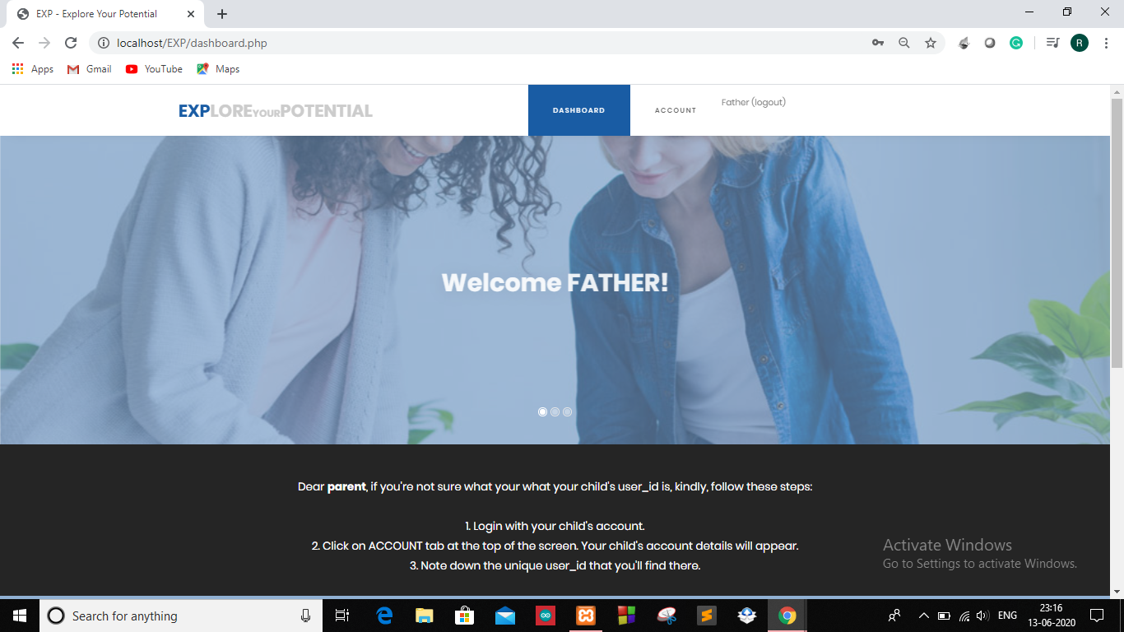

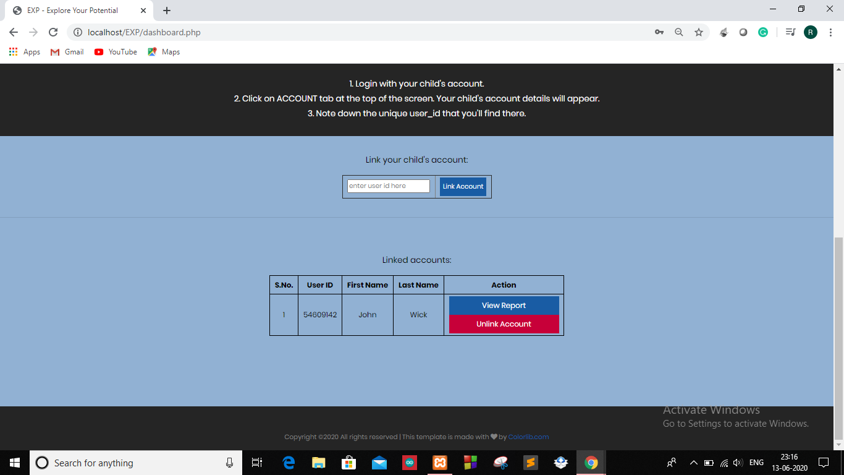

**6.Admin Login:**

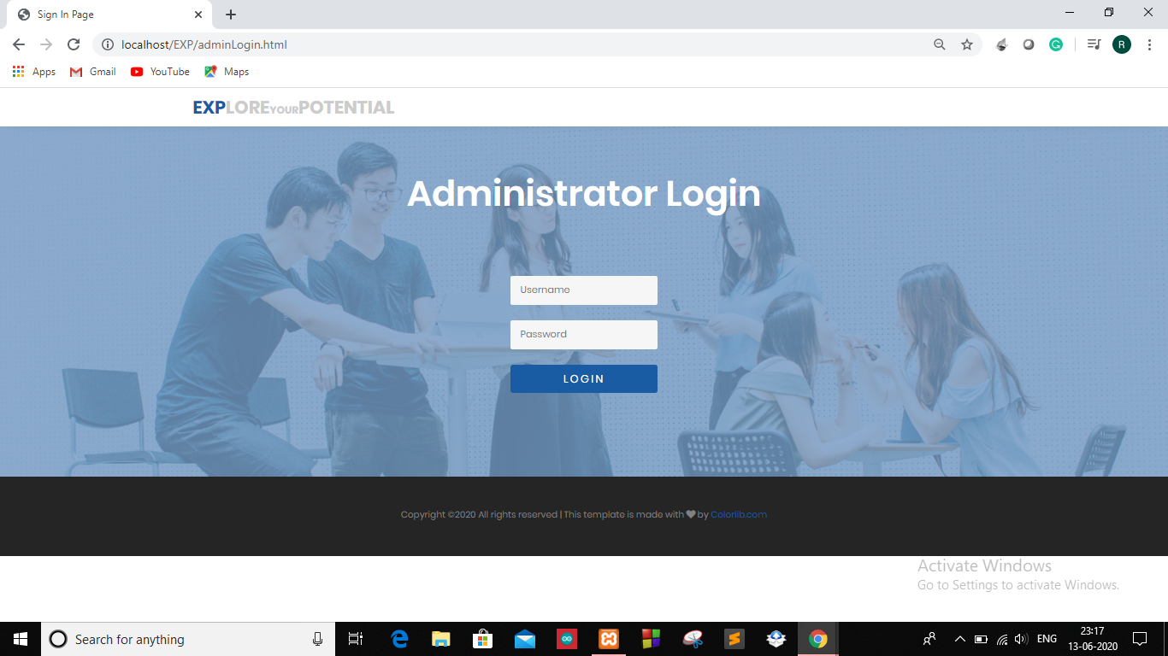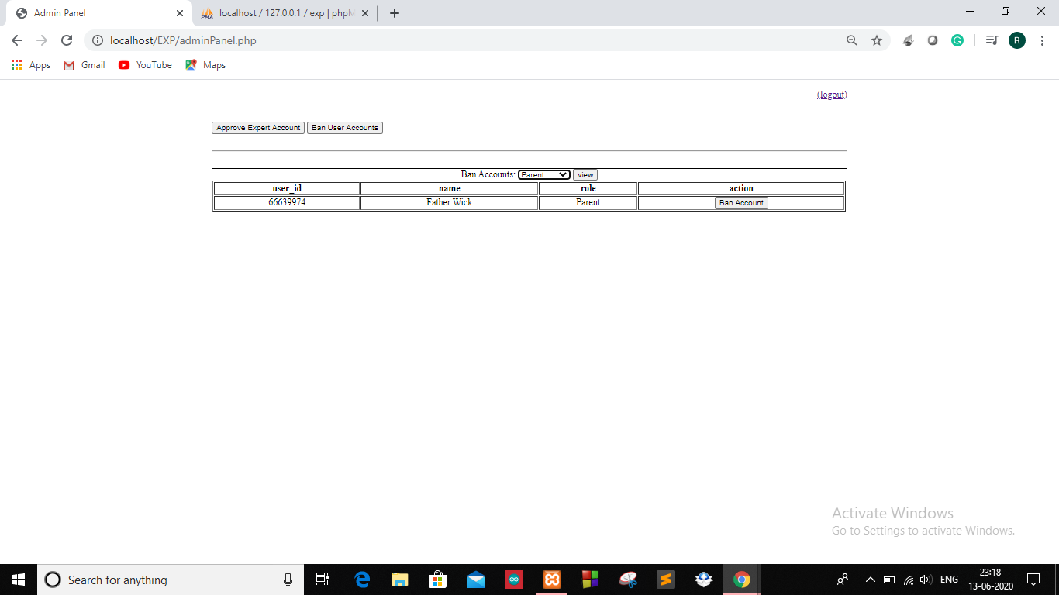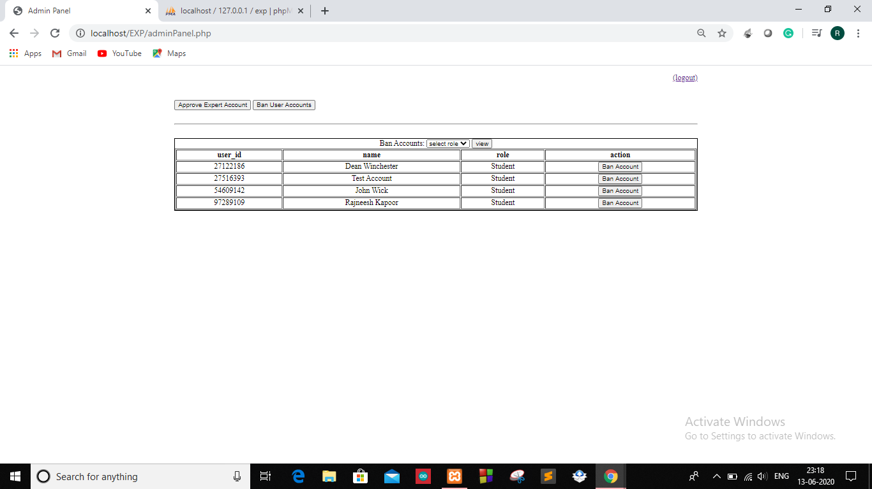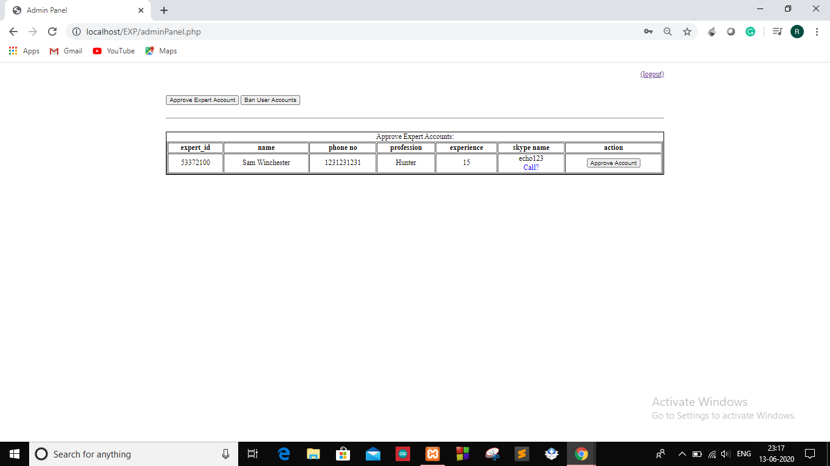

**7.Expert page:**

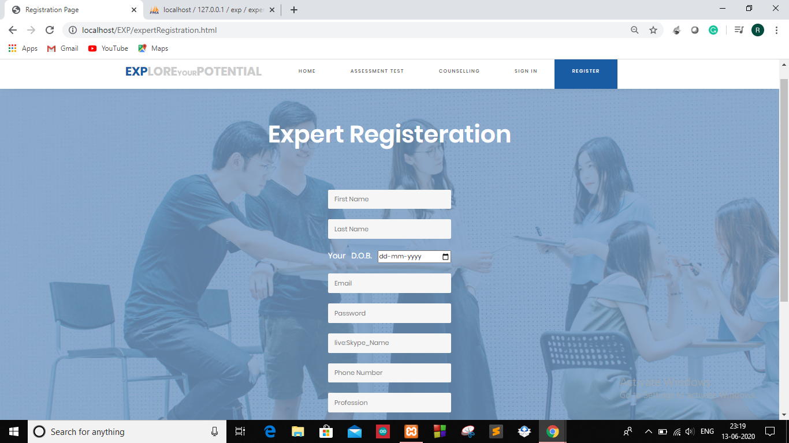 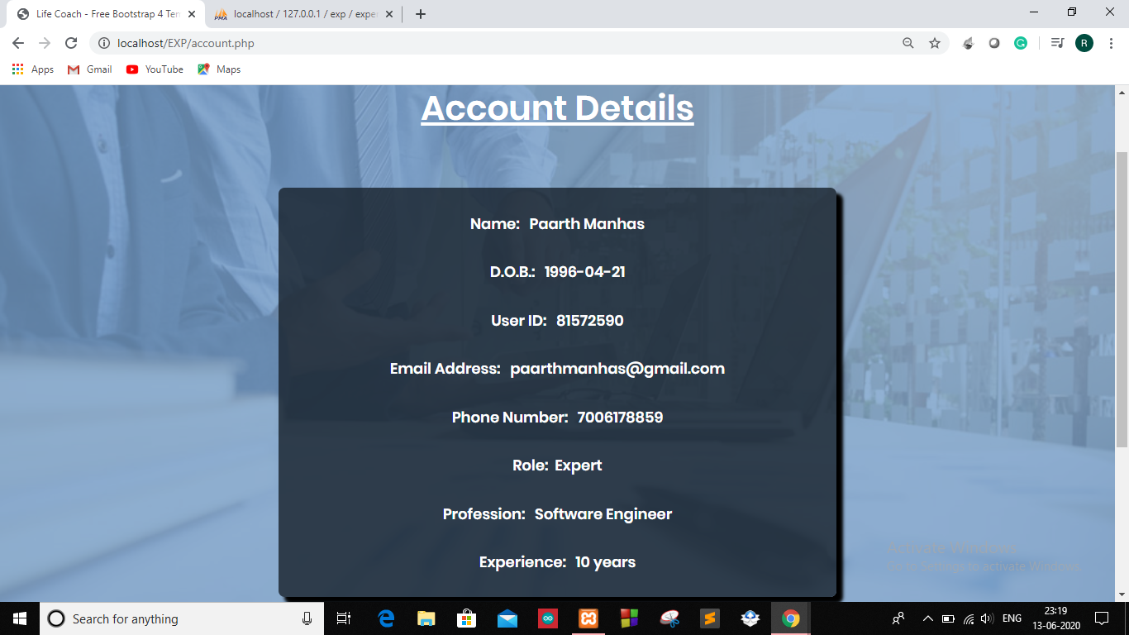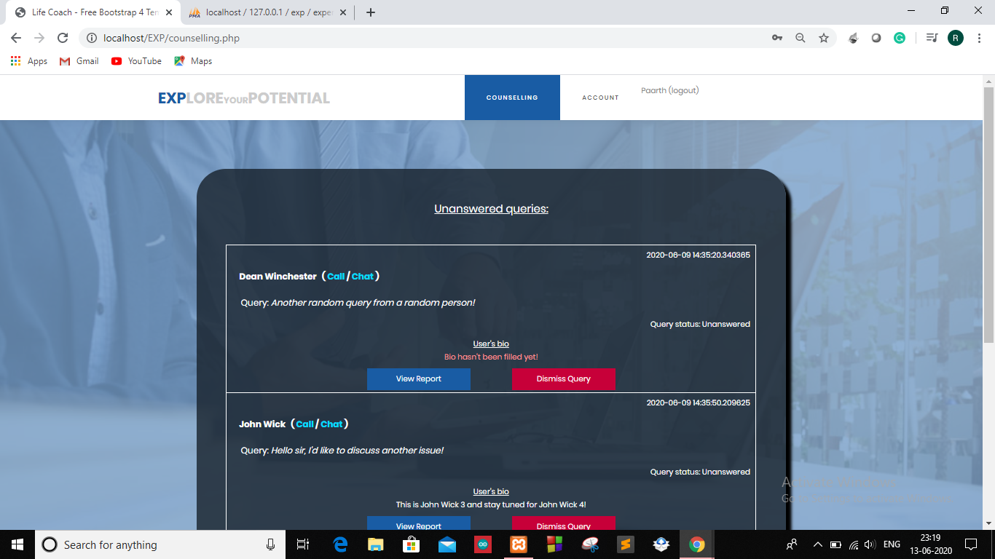

**8.**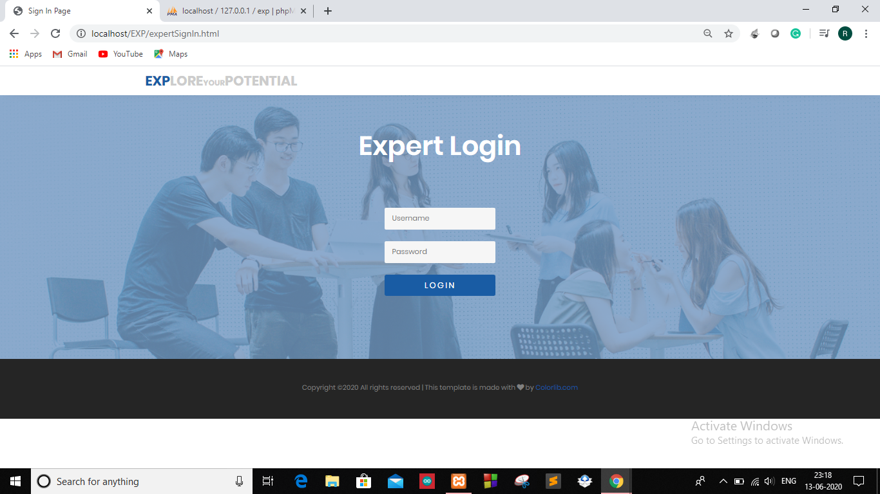

**11. Test Plan:**

The purpose of testing is to discover errors. Testing is the process of trying to discover every conceivable fault or weakness in a work product. It provides a way to check the functionalities of components, sub assemblies, and/or a finished product it is the process of exercising software with the intent of ensuring that the software system meets its requirements and user expectations and does not fail in an unacceptable manner. There are various types of tests. Each test type addresses a specific testing requirement.

Functional Test:-

❖ Validation assigned for various inputs.

❖ Accurate entry of records in a database.

❖ Security authentication.

❖ Management of various databases.

Performance Test:-

• Proper feedback report generated by the system.

• Faster access and loading of feedbacks of customer.

**12. Project Legacy:**

**12.1) Current Status of Project:**

* The project is functionally ready to use.
* Design part of project is almost done.
* Admin panel, end user, expert panels are completed.

**12.2) Remaining areas of Concern**

* Project minute errors has not been thoroughly checked ,if they exist.
* Minute area of question part.

**12.3) Technical and Managerial Lessons learned:**

* How to handle complex databases.
* Managing of the various part of the project such as-designing ,managing databases ,functionality ,resources ,etc.
* Managing the work among team-mates.
* Storing of the records , performing the various function on the database

**12.4) Future Recommendations**

* Integrating the project with add on functionality.
* Conversion of the website into fully functional application.
* Updating the security version to more secure version

**13.Biblography:**

https://www.quora.com/What-are-the-best-sites-for-career-counselling

https://www.mindler.com

https://www.idreamcareer.com

https://www.assessmentday.co.uk/psychometric-test.html.

**14.Appendix:**

All the source code files and database are in this drive.

<https://drive.google.com/open?id=1DWeGXgdFmPOE1FygB0HyuRyofjtM3V5j>